2.7 Promises and Async

This section will guide you to:

* Create a JavaScript project in your IDE
* Write a program in JavaScript to create promises

This lab has three subsections, namely:

2.7.1 Writing a program in JavaScript to verify implementations of promises with async

2.7.2 Executing the program and verifying working of promises

2.7.3 Pushing the code to your GitHub repositories

**Step 2.7.1:** Writing a program in JavaScript to verify implementations of promises with async

* Open Visual Studio Code
* *[Right click]* on the **src** folder of the project
* Select *New File* -> Enter the filename as **index.html**
* Write the code shown below resolving the warning and errors due compatibility-related issues

<html>

<body>

<h1>MEAN Stack</h1>

<p> Lesson 2 Demos </p>

<script src="Promises.js"></script>

</body>

</html>

* *[Right click]* on the **src** folder of the project
* Select *New File* -> Enter the filename as **Promises.js**
* Execute the code shown below resolving the warning and errors due compatibility-related issues

function flippingACoin() {

return new Promise((resolve, reject) => {

const val = Math.round(Math.random() * 1); // 0 or 1, at random

val ? resolve('Heads!!') : reject('Tails!!');

});

}

async function result() {

try {

const result = await flippingACoin();

console.log(result);

} catch(err) {

console.log(err);

}

}

result();

result();

result();

result();

result();

**Step 2.7.2:** Executing the program and verifying working of promises

Before you execute the program, check for syntactical corrections. If no errors are found, follow the steps mentioned below:

* Go to Extensions and download **Live Server**
* *[Right click]* on the **index.html** file of the project
* Select *Open with Live Server*
* Right click when the server starts running. Select *Inspect Element*.Click on **Console**

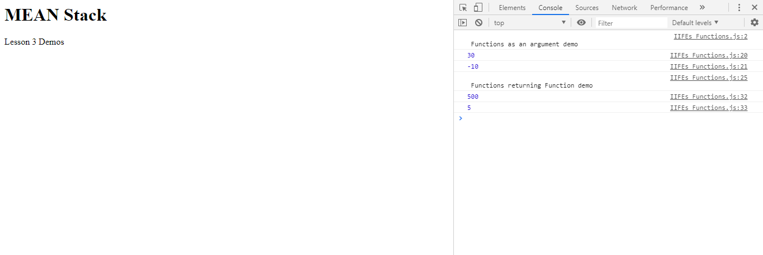

**Step 2.7.3:** Pushing the code to your GitHub repositories

Open your command prompt and navigate to the folder where you have created your files.

cd <folder path>

Initialize your repository using the following command:

git init

Add all the files to your git repository using the following command:

git add . 

Commit the changes using the following command:

git commit . -m “Changes have been committed.”

Push the files to the folder you initially created using the following command:

git push -u origin master